**DATA HANDLER**

**SPLASH SCREEN**

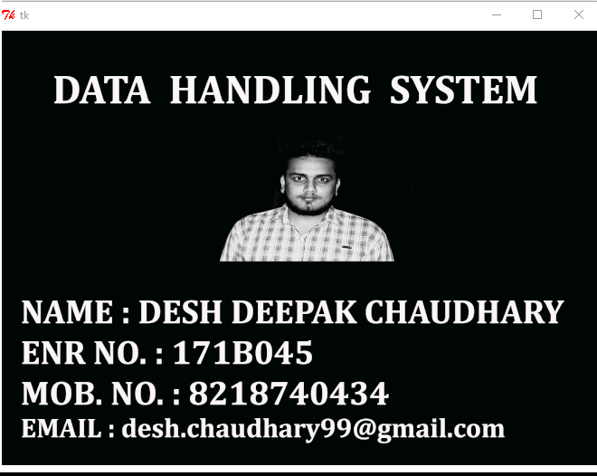

**MAIN SCREEN**

**It manages the data provided by the user and stores them in a database which can be used to fetch details for some later use, the project doesn’t specify its audience, one can use this just by opening it, it doesn’t need any special requirements and can be used just by reading the instructions which pop up everytime.**

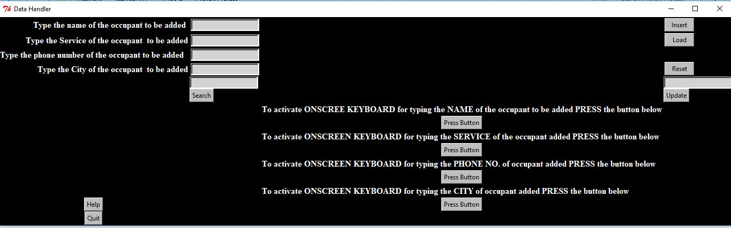

**It has various functions –**

**BUTTONS**

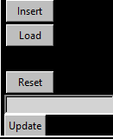

**INSERT BUTTON**

**Insert Button basically inserts the the entries in a database.**

**RESET BUTTON**

**We can use Reset Button for the deletion of the data stored in database,it resets the whole database in one go where you don’t have to delete the entries.**

**UPDATE BUTTON**

**We can also update the given entries with the help of Update Button , if it has some wrong details, it is helpful for later use also**

**when the user want to update or change the values of the data earlier given.**

**SEARCH BUTTON**

**Search Button is also there which can search the details of the person by providing the name of the of the person to be searched.**

**HELP BUTTON**

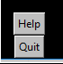

**Help Button is there to help the user if it has any problem in understanding the procedure of how this handler works.**

**THE QUIT BUTTON**

**At last, it has Quit Button which is used to close the Handler.**

**ONSCREEN KEYBOARDS**

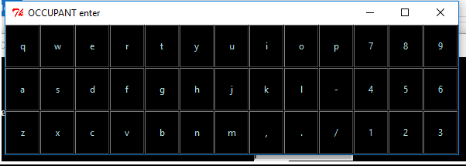

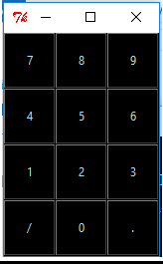

**It also has it’s own on screen keyboard for entering details of various Entries, if the user is unable to access the keyboard then he/she can access the data or can write the data with the help of mouse itself.**